14.26: a) Neglecting the density of the air,

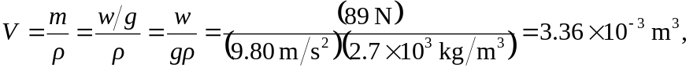

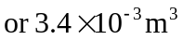to two figures.

b)